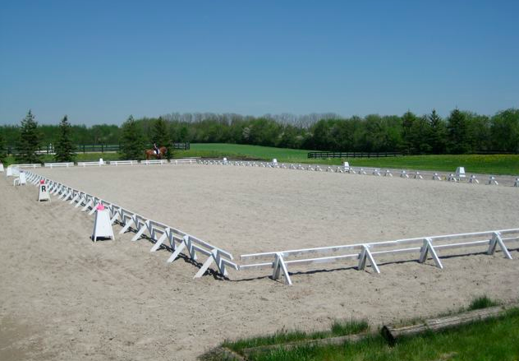
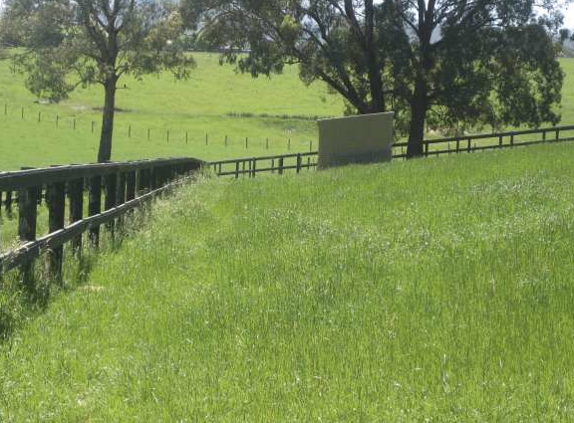
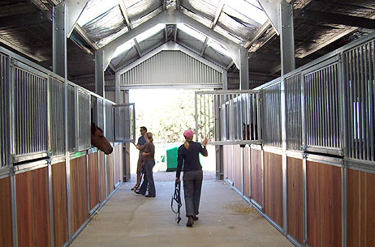
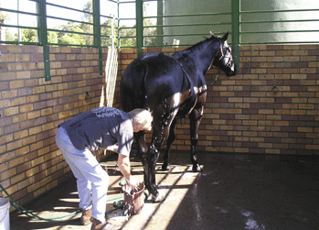
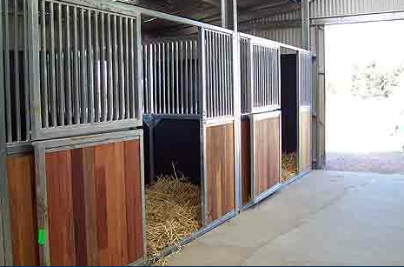
Horse Agistment

45 acre property

perfect environment for spelling, brood, retirement or working horses.

Private paddocks

own shelters,

auto water trough, Unlimited water supply.

electric fencing

Excellent pasture

Facilties
- dressage sand arena
- Show jumping arena
- Farriers, dentists and vet on propertly
- State forest (10 min ride)
- Full Care
- Self Care
- Wash Bay
Stabling
- Large private paddock
- Tack, Float & Feed storage
- Washing machine
- Rugging as required & rug repairs
- Riding lessons available
- School horses available if you don't have your own horse
Close to pony clubs, jump club & dressage clubs

Please call April on 0429 978 588

